2.1 Task 1: Encryption using Different Ciphers and Modes

I encrypted my text file in all listed encryption methods. I got a pretty much the same encrypted texts in all three methods.

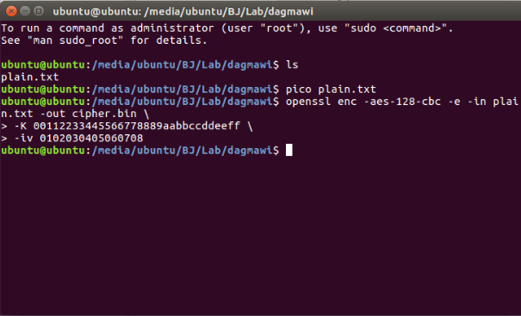

Encrypting via aes-128-cbc

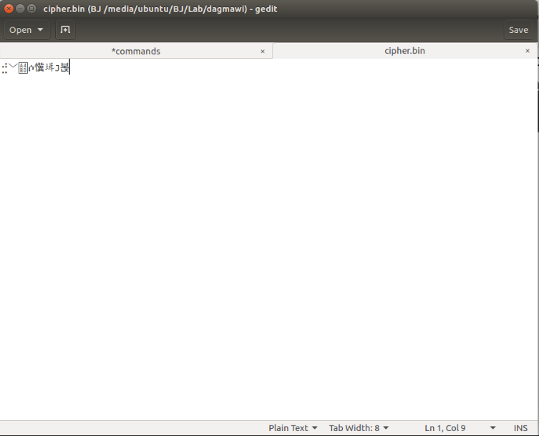

The encrypted text of aes-128-cbc

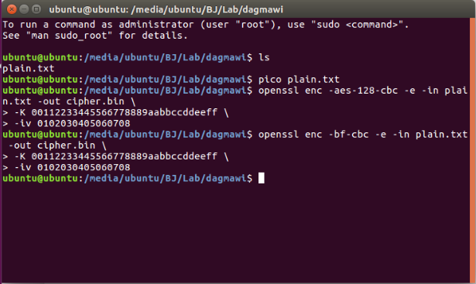

Encrypting via bf-cbc

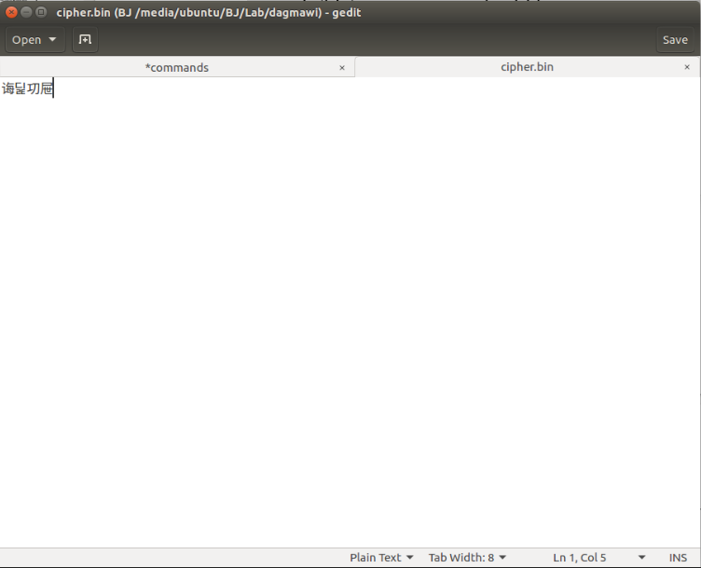

The encrypted text of bf-cbc

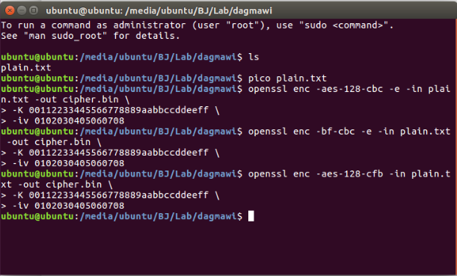

Encrypting via aes-128-cfb

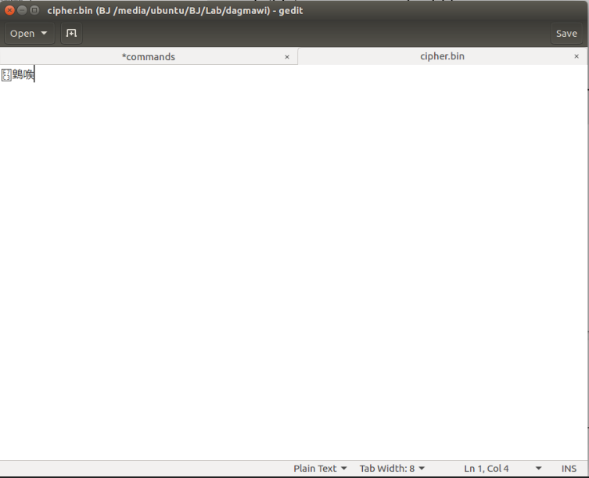

Encrypted text aes-128-cfb

2.2 Task 2: Encryption Mode – ECB vs. CBC

I downloaded the image and worked what was asked which was to encrypt by dividing in to two. Then build the image back (decrypt).

 The original image



The header that I got with CBC

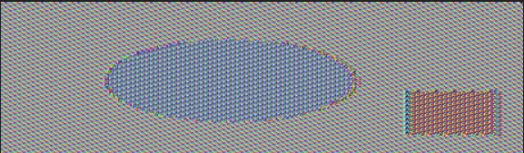

The header that I got with ECB

 Extracted Image

I can clearly see what in the image in the case of ECB header so I think CBC did a better job here.

2.3 Task 4: Padding

I made files called f5 (5 bytes), f10 (10 bytes), f15 (15 bytes). Then encrypted in the ordered encryption methods.

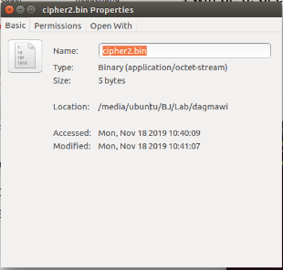

F5 cfb result

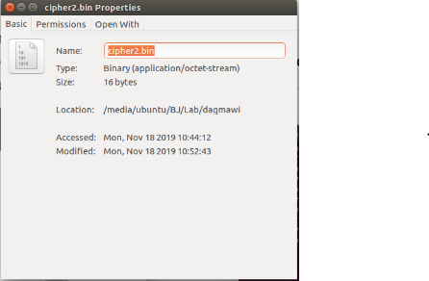

F5 ecb result

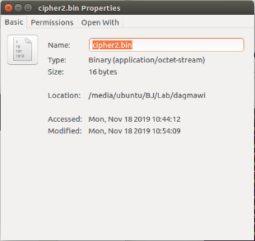

f10 ecb results

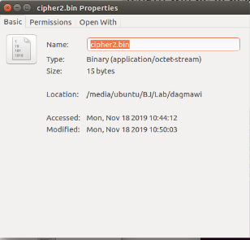

f15 cfb result

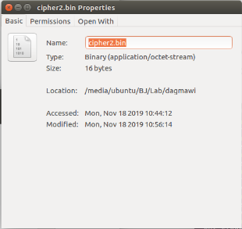

f15 ecb results

As you can see in the above screenshots whenever I encrypted via cfb and ofb it gives me the exact size as the encrypted file.

And for the other two, they printed 16 bytes. When I tried in 20 bytes of file it printed a size of 32 bytes.